Designed using Avery product 28877.

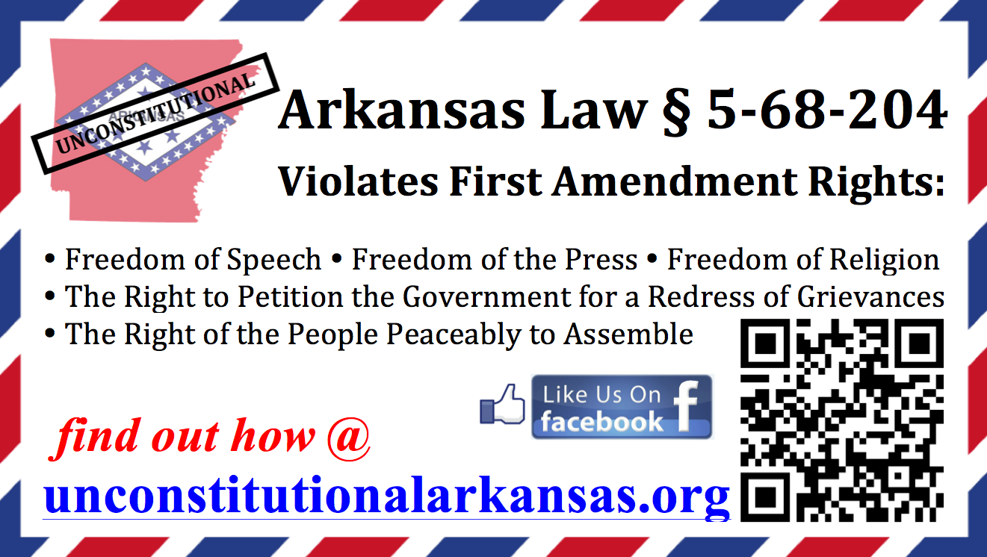

Arkansas law § 5-68-204 makes it illegal to be nude in the presence of the opposite gender. (There are only two exceptions: you are either legally married, or the other person is a doctor or nurse.) This law specifically targets PRIVATE PROPERTY. But what is most astonishing is that this law violates the First Amendment’s “Freedom of Speech” by making it ILLEGAL TO “ADVOCATE” (i.e. speak in favor of) nudism. (It is legal for critics to make derogatory statements about nudism, but if a naturist responds with information or opinions favorable to nudism, he or she is breaking this law.) Regardless of your view on nudism, I would hope that every American would feel indignant at the notion of a body of government that is so arrogant in its power that it has outlawed its citizens from having an informed and intelligent discussion about the topic. This is not just an "Arkansas" issue. If one state can outlaw free speech on a specific topic, then any other local, state, or federal government can use similar language to outlaw topics they consider to be "obscene". | Arkansas law § 5-68-204 makes it illegal to be nude in the presence of the opposite gender. (There are only two exceptions: you are either legally married, or the other person is a doctor or nurse.) This law specifically targets PRIVATE PROPERTY. But what is most astonishing is that this law violates the First Amendment’s “Freedom of Speech” by making it ILLEGAL TO “ADVOCATE” (i.e. speak in favor of) nudism. (It is legal for critics to make derogatory statements about nudism, but if a naturist responds with information or opinions favorable to nudism, he or she is breaking this law.) Regardless of your view on nudism, I would hope that every American would feel indignant at the notion of a body of government that is so arrogant in its power that it has outlawed its citizens from having an informed and intelligent discussion about the topic. This is not just an "Arkansas" issue. If one state can outlaw free speech on a specific topic, then any other local, state, or federal government can use similar language to outlaw topics they consider to be "obscene".
Arkansas law § 5-68-204 makes it illegal to be nude in the presence of the opposite gender. (There are only two exceptions: you are either legally married, or the other person is a doctor or nurse.) This law specifically targets PRIVATE PROPERTY. But what is most astonishing is that this law violates the First Amendment’s “Freedom of Speech” by making it ILLEGAL TO “ADVOCATE” (i.e. speak in favor of) nudism. (It is legal for critics to make derogatory statements about nudism, but if a naturist responds with information or opinions favorable to nudism, he or she is breaking this law.) Regardless of your view on nudism, I would hope that every American would feel indignant at the notion of a body of government that is so arrogant in its power that it has outlawed its citizens from having an informed and intelligent discussion about the topic. This is not just an "Arkansas" issue. If one state can outlaw free speech on a specific topic, then any other local, state, or federal government can use similar language to outlaw topics they consider to be "obscene". | Arkansas law § 5-68-204 makes it illegal to be nude in the presence of the opposite gender. (There are only two exceptions: you are either legally married, or the other person is a doctor or nurse.) This law specifically targets PRIVATE PROPERTY. But what is most astonishing is that this law violates the First Amendment’s “Freedom of Speech” by making it ILLEGAL TO “ADVOCATE” (i.e. speak in favor of) nudism. (It is legal for critics to make derogatory statements about nudism, but if a naturist responds with information or opinions favorable to nudism, he or she is breaking this law.) Regardless of your view on nudism, I would hope that every American would feel indignant at the notion of a body of government that is so arrogant in its power that it has outlawed its citizens from having an informed and intelligent discussion about the topic. This is not just an "Arkansas" issue. If one state can outlaw free speech on a specific topic, then any other local, state, or federal government can use similar language to outlaw topics they consider to be "obscene".
Arkansas law § 5-68-204 makes it illegal to be nude in the presence of the opposite gender. (There are only two exceptions: you are either legally married, or the other person is a doctor or nurse.) This law specifically targets PRIVATE PROPERTY. But what is most astonishing is that this law violates the First Amendment’s “Freedom of Speech” by making it ILLEGAL TO “ADVOCATE” (i.e. speak in favor of) nudism. (It is legal for critics to make derogatory statements about nudism, but if a naturist responds with information or opinions favorable to nudism, he or she is breaking this law.) Regardless of your view on nudism, I would hope that every American would feel indignant at the notion of a body of government that is so arrogant in its power that it has outlawed its citizens from having an informed and intelligent discussion about the topic. This is not just an "Arkansas" issue. If one state can outlaw free speech on a specific topic, then any other local, state, or federal government can use similar language to outlaw topics they consider to be "obscene". | Arkansas law § 5-68-204 makes it illegal to be nude in the presence of the opposite gender. (There are only two exceptions: you are either legally married, or the other person is a doctor or nurse.) This law specifically targets PRIVATE PROPERTY. But what is most astonishing is that this law violates the First Amendment’s “Freedom of Speech” by making it ILLEGAL TO “ADVOCATE” (i.e. speak in favor of) nudism. (It is legal for critics to make derogatory statements about nudism, but if a naturist responds with information or opinions favorable to nudism, he or she is breaking this law.) Regardless of your view on nudism, I would hope that every American would feel indignant at the notion of a body of government that is so arrogant in its power that it has outlawed its citizens from having an informed and intelligent discussion about the topic. This is not just an "Arkansas" issue. If one state can outlaw free speech on a specific topic, then any other local, state, or federal government can use similar language to outlaw topics they consider to be "obscene".
Arkansas law § 5-68-204 makes it illegal to be nude in the presence of the opposite gender. (There are only two exceptions: you are either legally married, or the other person is a doctor or nurse.) This law specifically targets PRIVATE PROPERTY. But what is most astonishing is that this law violates the First Amendment’s “Freedom of Speech” by making it ILLEGAL TO “ADVOCATE” (i.e. speak in favor of) nudism. (It is legal for critics to make derogatory statements about nudism, but if a naturist responds with information or opinions favorable to nudism, he or she is breaking this law.) Regardless of your view on nudism, I would hope that every American would feel indignant at the notion of a body of government that is so arrogant in its power that it has outlawed its citizens from having an informed and intelligent discussion about the topic. This is not just an "Arkansas" issue. If one state can outlaw free speech on a specific topic, then any other local, state, or federal government can use similar language to outlaw topics they consider to be "obscene". | Arkansas law § 5-68-204 makes it illegal to be nude in the presence of the opposite gender. (There are only two exceptions: you are either legally married, or the other person is a doctor or nurse.) This law specifically targets PRIVATE PROPERTY. But what is most astonishing is that this law violates the First Amendment’s “Freedom of Speech” by making it ILLEGAL TO “ADVOCATE” (i.e. speak in favor of) nudism. (It is legal for critics to make derogatory statements about nudism, but if a naturist responds with information or opinions favorable to nudism, he or she is breaking this law.) Regardless of your view on nudism, I would hope that every American would feel indignant at the notion of a body of government that is so arrogant in its power that it has outlawed its citizens from having an informed and intelligent discussion about the topic. This is not just an "Arkansas" issue. If one state can outlaw free speech on a specific topic, then any other local, state, or federal government can use similar language to outlaw topics they consider to be "obscene".
Arkansas law § 5-68-204 makes it illegal to be nude in the presence of the opposite gender. (There are only two exceptions: you are either legally married, or the other person is a doctor or nurse.) This law specifically targets PRIVATE PROPERTY. But what is most astonishing is that this law violates the First Amendment’s “Freedom of Speech” by making it ILLEGAL TO “ADVOCATE” (i.e. speak in favor of) nudism. (It is legal for critics to make derogatory statements about nudism, but if a naturist responds with information or opinions favorable to nudism, he or she is breaking this law.) Regardless of your view on nudism, I would hope that every American would feel indignant at the notion of a body of government that is so arrogant in its power that it has outlawed its citizens from having an informed and intelligent discussion about the topic. This is not just an "Arkansas" issue. If one state can outlaw free speech on a specific topic, then any other local, state, or federal government can use similar language to outlaw topics they consider to be "obscene". | Arkansas law § 5-68-204 makes it illegal to be nude in the presence of the opposite gender. (There are only two exceptions: you are either legally married, or the other person is a doctor or nurse.) This law specifically targets PRIVATE PROPERTY. But what is most astonishing is that this law violates the First Amendment’s “Freedom of Speech” by making it ILLEGAL TO “ADVOCATE” (i.e. speak in favor of) nudism. (It is legal for critics to make derogatory statements about nudism, but if a naturist responds with information or opinions favorable to nudism, he or she is breaking this law.) Regardless of your view on nudism, I would hope that every American would feel indignant at the notion of a body of government that is so arrogant in its power that it has outlawed its citizens from having an informed and intelligent discussion about the topic. This is not just an "Arkansas" issue. If one state can outlaw free speech on a specific topic, then any other local, state, or federal government can use similar language to outlaw topics they consider to be "obscene".

